DAA LAB ASSIGNMENT – 3
Course: Design and Analysis of Algorithms (DAA)
Student Name: Lavanyadevi K
Student Reg. No: CH.SC.U4CSE24226
Student Department/Class: B. Tech CSE – C (2nd yr)

Q1. Breadth First Search (BFS)

Question
Write a C program to perform Breadth First Search (BFS) traversal of a graph.

Algorithm
- Read the number of vertices in the graph.
- Read the adjacency matrix.
- Initialize a visited array with all values as 0.
- Insert the starting vertex into the queue and mark it as visited.
- Remove a vertex from the queue and print it.
- Visit all its adjacent vertices that are not visited.
- Mark them as visited and insert them into the queue.
- Repeat steps until the queue becomes empty.

C Program
#include <stdio.h>

int queue[20], front = -1, rear = -1;
int visited[20], adj[20][20], n;

void enqueue(int v) {
if (rear == n - 1)
return;
queue[++rear] = v;
}

int dequeue() {
return queue[++front];
}

void bfs(int start) {
enqueue(start);
visited[start] = 1;

while (front != rear) {
int v = dequeue();
printf("%d ", v);

for (int i = 0; i < n; i++) {
if (adj[v][i] == 1 && visited[i] == 0) {
enqueue(i);
visited[i] = 1;
}
}
}
}

int main() {
int start;
printf("Enter number of vertices: ");
scanf("%d", &n);

printf("Enter adjacency matrix:\n");
for (int i = 0; i < n; i++)
for (int j = 0; j < n; j++)
scanf("%d", &adj[i][j]);

printf("Enter starting vertex: ");
scanf("%d", &start);

bfs(start);
return 0;
}

Output

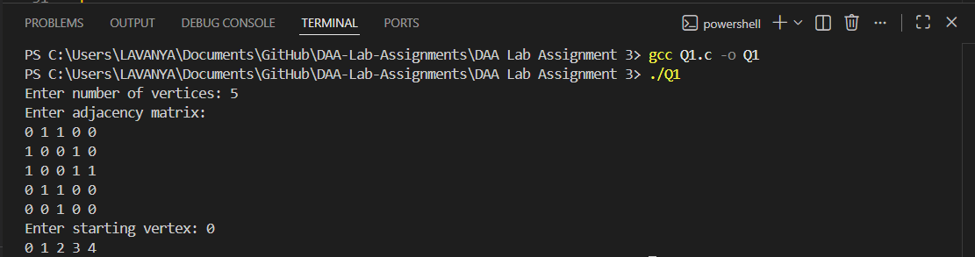

Interpretation
Breadth First Search visits all vertices level by level starting from a given vertex.
It uses a queue to ensure that vertices are visited in the order they are discovered.
BFS is useful for finding shortest paths and level-wise traversal of graphs.

Q2. Depth First Search (DFS)

Question
Write a C program to perform Depth First Search (DFS) traversal of a graph.

Algorithm
- Read the number of vertices.
- Read the adjacency matrix.
- Initialize all vertices as not visited.
- Start DFS from a given vertex.
- Mark the vertex as visited and print it.
- Recursively visit all unvisited adjacent vertices.
- Continue until all vertices are visited.

C Program
#include <stdio.h>

int adj[20][20], visited[20], n;

void dfs(int v) {
printf("%d ", v);
visited[v] = 1;

for (int i = 0; i < n; i++) {
if (adj[v][i] == 1 && visited[i] == 0) {
dfs(i);
}
}
}

int main() {
int start;
printf("Enter number of vertices: ");
scanf("%d", &n);

printf("Enter adjacency matrix:\n");
for (int i = 0; i < n; i++)
for (int j = 0; j < n; j++)
scanf("%d", &adj[i][j]);

printf("Enter starting vertex: ");
scanf("%d", &start);

dfs(start);
return 0;
}

Output

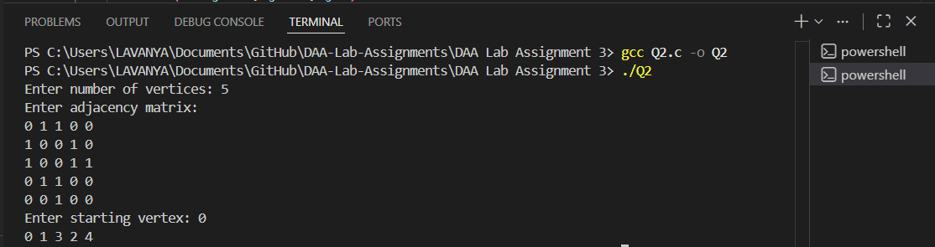

Interpretation
Depth First Search explores a graph by going as deep as possible before backtracking.
It uses recursion to visit adjacent vertices one by one.
DFS is useful in applications such as cycle detection and path finding.

